**Housing Markets Trends for Inner Melbourne Suburbs**

Project Proposal

Elizabeth Dashwood, Lindsay McCulloch, Violet Bui, Vrinda Patel

## **1. Background**

Trends in the housing market is a popular topic of discussion for many, including future and current homeowners, property investors and city planners. This trend has been analysed by comparing residential pricing data against two different metrics.

### **1.1. Data Used**

Four data sets were used for this analysis:

**1.1.1. House/Townhouse and Apartment Prices**

Median selling price for residences and number of transactions for inner Melbourne small areas. This data is grouped by year, small area and house/townhouse or apartment. It covers the period between 2000 and 2016.

This data is sourced from the City of Melbourne Open Data. It can be found here “<https://data.melbourne.vic.gov.au/explore/dataset/house-prices-by-small-area-sale-year/information/>” and was accessed through using their API.

**1.1.2. Household Income Data**

Breakdown of total household income in Victoria (in millions of AUD). The gross disposable, total gross, and total payable income have been specified. The data is grouped by two year periods. This data also specifies the estimated number of households for the surveyed population. It covers the period between 2003-2019.

This data is sourced from the Australian Bureau of Statistics Census Data. It can be found here “<https://www.abs.gov.au/statistics/economy/national-accounts/australian-national-accounts-distribution-household-income-consumption-and-wealth/latest-release#data-downloads>” and was downloaded as a csv file. Using only the CSV for Household Income data titled “5204055011do001.csv”

**1.1.3. Population and Suburb Data**

Population counts by suburb. This data is grouped by year and suburb, and specifies total population and area (sqkm). It covers the years 2011, 2016 and 2021.

This data is sourced from the Australian Bureau of Statistics Census Data. It can be found at the sites below, and was downloaded as .csv and .xlsx files.

2021 data: <https://www.abs.gov.au/census/find-census-data/datapacks?release=2021&product=GCP&geography=ALL&header=S> using only the following files from the Victoria DataPack

“2021Census_G03_VIC_SAL.csv” file for population data, and “2021Census_geog_desc_1st_2nd_3rd_release.xlsx” metadata file for the suburb names

2016 data: <https://www.abs.gov.au/census/find-census-data/datapacks?release=2016&product=GCP&geography=ALL&header=S> using only the following files from the Victoria DataPack

“2016Census_G03_VIC_SSC.csv” file for population data, and “2016Census_geog_desc_1st_and 2nd_release.xlsx” metadata file for suburb names

2011 data: <https://www.abs.gov.au/census/find-census-data/datapacks?release=2011&product=BCP&geography=ALL&header=S> using only the following files from the Victoria DataPack

“2011Census_B03_VIC_SSC_short.csv” file for population data, and “2011Census_geog_desc_1st_and_2nd_release.xlsx” metadata file for suburb names

**1.1.4. Interest Rate Data**

This data is sourced from the Reserve Bank of Australia. It can be found at the sites below, and was downloaded as .xlsx files.

Interest Rate Data: 2011 -2016

<https://www.rba.gov.au/statistics/cash-rate/>

## **2. Analysis**

### **2.1. Residence Prices Against Household Income**

**Question 1: What trends can be observed in median income per 2 year period vs median residence cost per 2 year period?**

(LM)

In order to answer this question the data below has been sourced from the median household income census data from the Australian Bureau of Statistics (ABS).

Summary table of data can be found below, recording total number of households participating in the census and the type of income measure across a 17 year period.

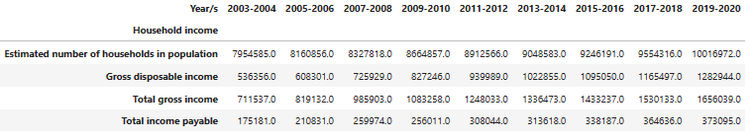

From the above table and as observable in the below bar chart, we can see that Total Gross Income has more than doubled at a total increase of *2.33 in Victoria with an increase of AUD 944,502.00 from 2003 to 2020.

*Note: all income points are measured in Millions (m) and years measured in two year increments.*

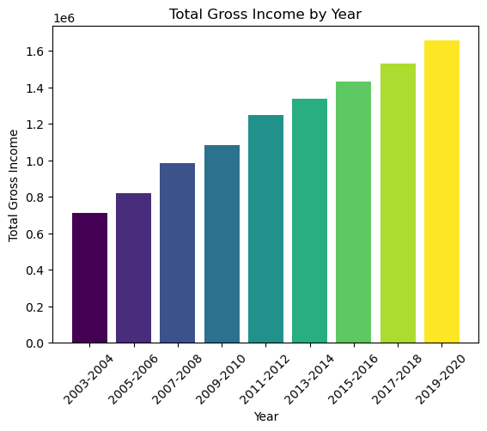

This same trend can also be observed in gross household disposable income; that being the funds that households have available for spending after deducting any taxes paid. These aforementioned taxes can also be observed in the Total Income Payable category; that being the amount that a household expects to pay in income taxes annually.

From the ABS data we can see Total Income Payable also doubled between this 17 year period.

Due to all income data points as sourced from the ABS maintaining this same trend, there is no statistical significance of tax payable amounts across the 17 years affecting the overall Gross Disposable Income amounts.

For the purpose of analysis Median Household Income has been used as the key income data for this analysis question. See below line graph for visualisation of income trends from 2003-2020.

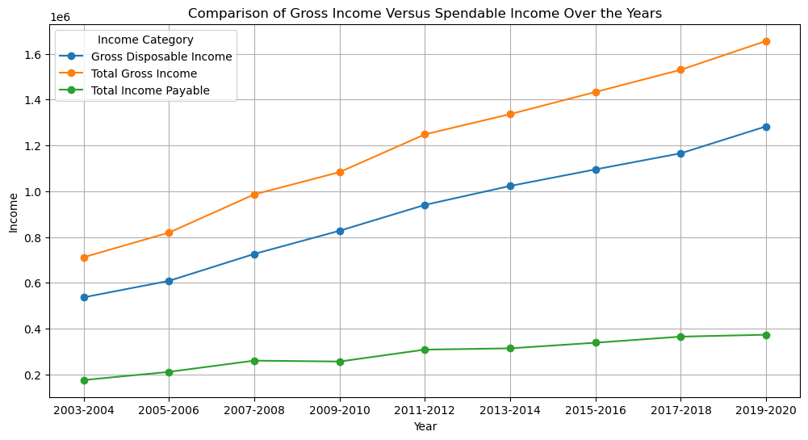

As the API data from the City of Melbourne Open Data was available from the years 2000 to 2016, for the purpose of analysis against Gross Household Income the data was limited to show data from 2003-2016 in two year intervals.

From the combined data as shown in the table below, it is observed that Median House prices overall have also more than doubled by *2.09 at a total median price from 2003 at AUD $436,554.57 to AUD $914, 250.33 in 2016 across both housing types; House/Townhouse and Residential apartments.

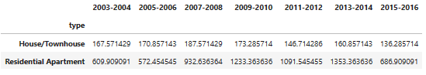

However unlike Median Income which had maintained an increasing upwards trend per two year period , the Median Residence Prices saw a decrease of AUD $2,662.59 between the 4 year period of 2009/2010 and 2011/2012 before again increasing per two year period.

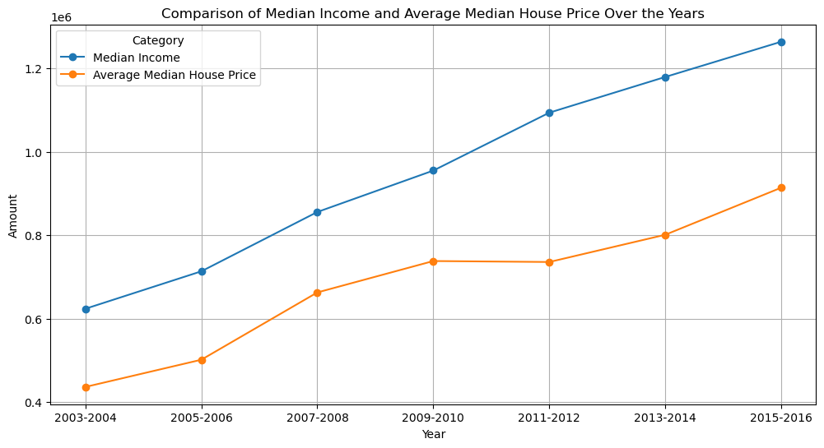

As we do have access to the median income data up until 2020 we can observe that this upwards trend does continue for Median Household Income and it can be hypothesised that the Median House Price for the next two year period 2017-2018 will maintain this same average difference of *1.59 between Median House Prices and Median Household Income, whilst both continuing to increase per two year period.

**Limitations:**

Some limitations of this data is that it is not current and cannot provide comparable information from 2016 onwards meaning we cannot predict future trends without more current information.

Further, the average household income was based on Victorian census data whereas the House Price data is based on Melbourne suburbs - meaning the data could be skewed based on proximity to Melbourne and may not provide a true indicator of all median house and income totals.

### **2.2. Household Affordability Index**

**Question 2: What is the housing affordability index for this period and what conclusions can be made based on various factors?**

A housing affordability index gauges how easily the average person or family in a specific area can afford housing and related expenses. It’s like a financial yardstick to assess whether housing costs are within reach for most people.

To calculate the affordability Index, we used the Interest Rate data from RBA, Average Median House Price and Median Income as shown in the below table.

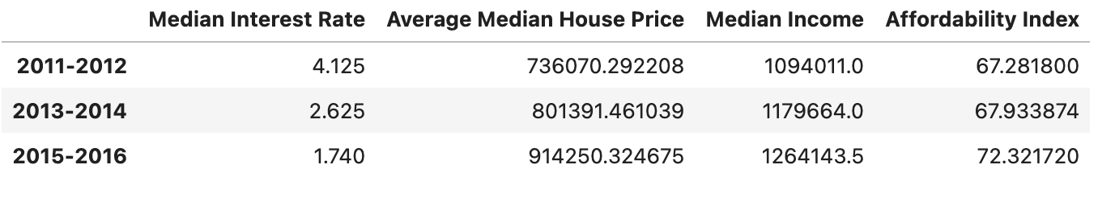

From the above table, we plotted a heatmap to compare each factor with Median House Price.

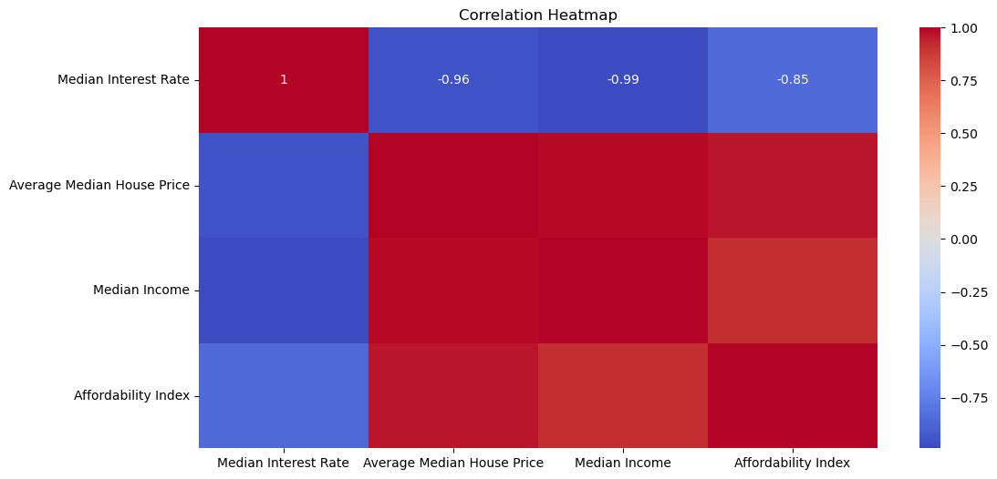

The graph represents the average median house prices in various suburbs. Each bar corresponds to a specific suburb, and the height of each bar indicates the median house price for that area. The significant variations in bar heights vividly highlight the differences in property values across different regions.

To infer conclusions based on household net income and house prices, we can analyse the following:

**Negative Correlation:** The strong negative correlation of -0.99 between median income and average median house price suggests that as income increases, housing becomes less affordable due to rising prices. In other words, higher incomes do not necessarily translate to better affordability.

**Regional Disparities:** The varying bar heights indicate substantial differences in property values across suburbs. Some areas may be more affordable than others, depending on factors like location, amenities, and demand.

**Income-Price Gap:** The gap between median income and median house prices highlights the challenge faced by households in affording homes. If this gap widens, it could lead to decreased affordability.

**Conclusion**:

The Affordability Index trends based on the graph spanning from 2003-2004 to 2015-2016:

During this period, the Affordability Index exhibited fluctuations. Initially, from 2003-2004 to 2007-2008, affordability increased. However, a sharp decline ensued from 2007-2008 to 2011-2012. Subsequently, there was a recovery, and affordability rose again until 2015-2016.

In summary, this graph highlights varying levels of affordability, impacting economic conditions over the years.

### 

### **2.3. Residence Prices Against Population**

**Question 3: Does the suburb population have any correlation with residence prices?**

* Using 2016 data, there was no correlation (-0.37) between the population and the median house prices for residential apartments in the suburbs of Inner Melbourne.

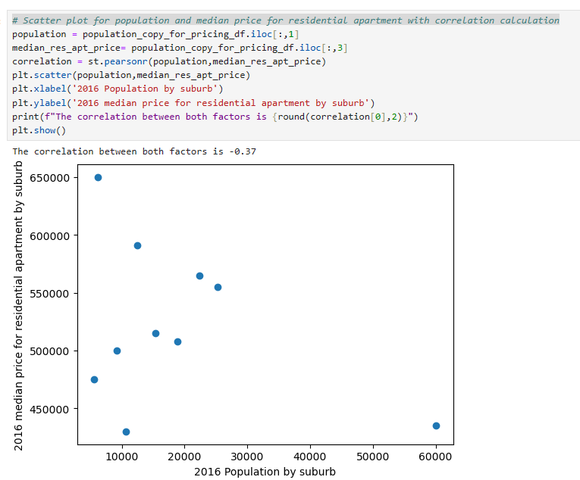

* Conversely, there was a slight correlation (0.25) between population and the median house prices for houses and townhouses in the 2016 data for Inner Melbourne, with 3 or 4 of the suburbs with lower populations also having the lower house prices.

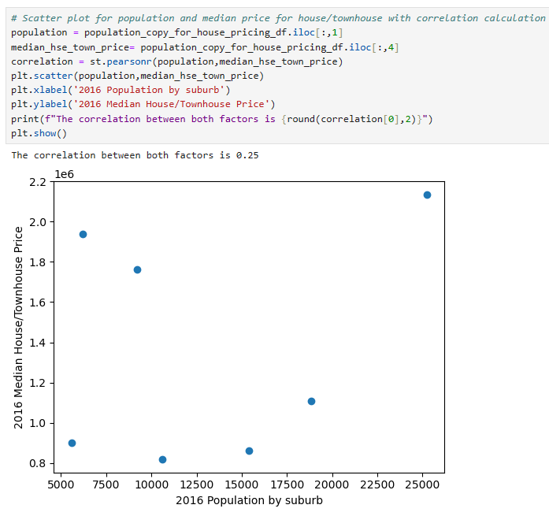

### **2.4. Residence Prices Against Population**

**Question 4: Does suburb population growth have any correlation with house prices?**

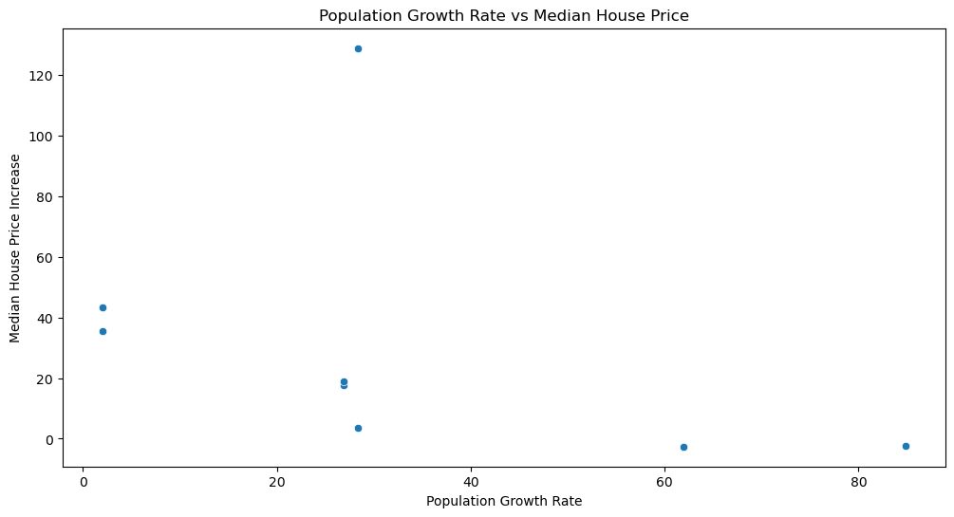

With the exception of one outlier piece of data, there seems to be a non-negligible negative correlation between the population growth of suburbs between 2011 and 2016, and the residential price increase in the same year span.

When removing this outlier, the correlation changes from -0.398 to -0.880:

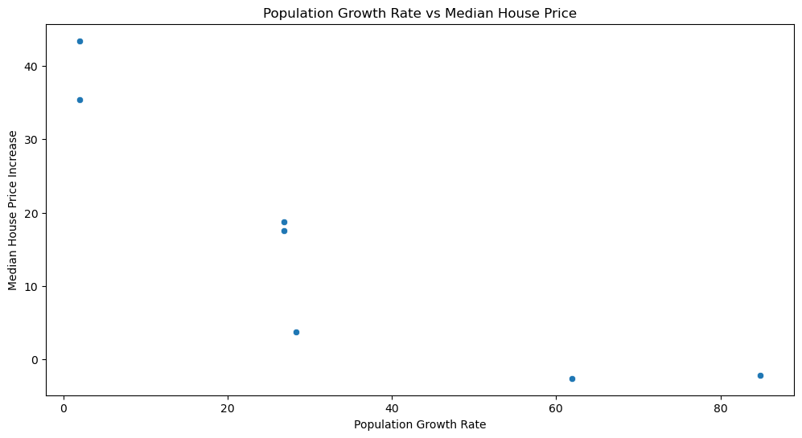

It is likely the data would fit an exponential or inverse model much more clearly.

## **3. Summary**

* Residential prices generally increase as median Victorian income increases
* There is a strong negative correlation between median residential prices and affordability index
* The correlation between population of a suburb and the median residential price for that suburb is very weak
* With the exception of one outlier, there is a good negative correlation between population growth and median residential price increase